**Brain Tumour Detection using Deep Learning [TentativeTitle]**

D Vamsidhar, Parth Desai, Sagar Shamjibhai Joshi

**ABSTRACT**

**INTRODUCTION**

Brain tumours, a significant concern for all professionals and care seekers in the field of healthcare due to its severe effects on both mental and physical health of the victims and on mortality too. Magnetic Resonance Imaging (MRI) is the biggest revolutionizing invention which has improved the quality of diagnosis of various health conditions and helped both doctors and patients irrespective of their economic background[1]. MRI produces high resolution images of internal organs of the human body like brain, pancreas, kidneys etc. Similarly, MRI helps in detecting brain tumours that form due to uncontrolled growth of brain cells which leads in the absorption of nutrients meant for healthy cells thus resulting in failure of other cells due to lack of nutrition.

Brain tumour is one of the most dangerous health disorders that a human body can manifest. It is typically classified into two types which are primary and secondary. A primary brain tumour forms in the brain itself and stays there, whereas a secondary brain tumour starts in a different part of the body and spreads to the brain [2].

**LITERATURE REVIEW**

1. Machine Learning Techniques

Various healthcare applications such as patient risk stratification, personalized medicine recommendations, electronic health records (EHR) data analytics. When it comes to brain tumour detection techniques and algorithms like RF, SVM, AdaBoost1 and RUSBoost to localize the brain tumour in the MRI Images [3].

The machine learning techniques use algorithms like SVM, random forest classifier and decision trees where the training data has brain MRI images and the segmented brain tumour for that image. For better results, the SVM algorithm was also modified like Proximal SVM and twin SVM. Proximal SVM is a simpler classification algorithm which considers all data points in the dataset instead of identifying support vectors and plotting the hyperplane and creates a boundary close to each class instead of increasing the margin of the margin. Twin SVM looks for two boundaries or hyperplanes, one hyperplane that is near to class1 and far from class 2 and second hyperplane that is near to class 2 and far from class 1 [4].

1. Deep Learning Techniques

We have many deep learning models used in various fields like finance, healthcare, technology, agriculture etc. but healthcare industry needs most solutions to complex problems like clinical image analysis, handling electronic health records and genomics which employ complex models like DeepBind, CNNs, RNNs, Human Activity Recognition (HAR), LSTMs which also require hyperparameter tuning and adjustment of learning rates for better results according to dataset. There are few challenges which employing deep learning models to solve the above problems which are volume of data, quality of data, progression of a disease, domain complexity and interpretability of deep learning models [5]. Another type of challenge faced heavily in the field of healthcare is increasing types of data which are electronic health records, genomic records, image dataset, X-Ray and MRI images increases the complexity of the code due to increased requirement of preprocessing and storage of data[5]. The diversity in the dataset brings the challenge of interpretability as different types of data needs separate way of preprocessing.

Existing projects that have produced high accuracy outputs use deep learning models like Gaussian Convolutional Neural Network (GCNN) on two datasets. These models produced an accuracy of 99.8% and 97.14% of accuracy on the two datasets. For image preprocessing the following methods like image cropping, rotating, flipping, inducing noise and transforming the colour space have been used [6].

1. Preprocessing Techniques

To have best predictions with high accuracy, precision and ideal recall values and f1 scores, it is necessary to preprocess the image dataset to capture maximum features from the images which will lead to better predictions and accuracy. Techniques like Intensity normalization, discrete wavelets-based decomposition, augmentation, ultra-light deep learning architecture-based feature extraction which creates a large impact on model performance because this helps the model to capture as many details as possible. Convolutional Neural Network was found to be better at executing the above techniques with application of L2 Regularization for improved generalization. To evaluate the performance of UL-BTD (Ultra-Light – Brain Tumour Detection) framework machine learning models like SVM, KNN and RF were employed [3].

To capture the details in a Brain MRI image for maximum output it is necessary to extract texture features from the images using methods like Gray-Level Co-occurrence Matrix (GLCM) [7]. The texture extraction can be done using multiple other techniques like Scale Invariant Feature Transform (SIFT), Saliency Detection. The application of SIFT and Saliency Detection are shown in Fig 1 and 2 respectively. As the figures clearly indicate, SIFT technique captures too many features from one image which makes it computationally expensive to work with and the Saliency Detection does not capture texture features of the internal part of the brain and only captures skull part which is not the desired output. Hence, both techniques were not used.

Fig .1 SIFT Features from Brain MRI Images

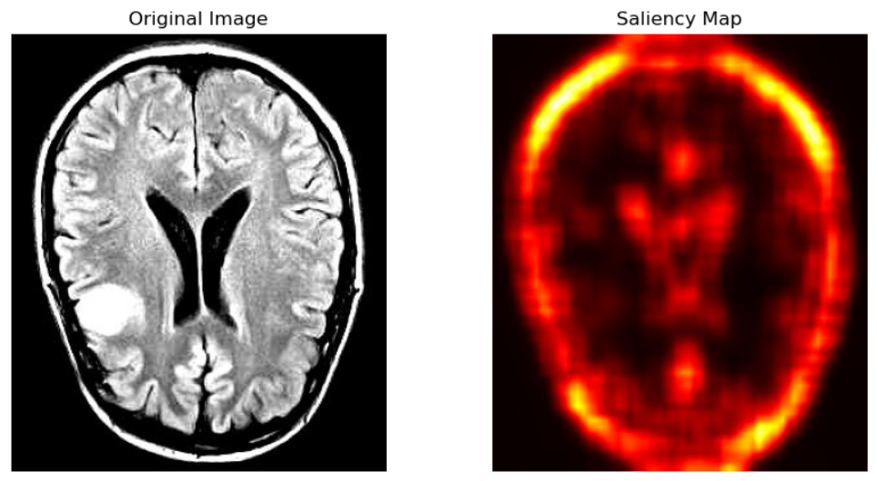

Fig .2 Saliency Detection from Brain MRI Images

METHODOLOGY

REFERENCES

[1] B. S. Hilabi, S. A. Alghamdi, and M. Almanaa, “Impact of Magnetic Resonance Imaging on Healthcare in Low- and Middle-Income Countries,” *Cureus*, Apr. 2023, doi: 10.7759/cureus.37698.

[2] H. ZainEldin *et al.*, “Brain Tumor Detection and Classification Using Deep Learning and Sine-Cosine Fitness Grey Wolf Optimization,” *Bioengineering*, vol. 10, no. 1, Jan. 2023, doi: 10.3390/bioengineering10010018.

[3] S. A. Qureshi *et al.*, “Intelligent Ultra-Light Deep Learning Model for Multi-Class Brain Tumor Detection,” *Applied Sciences (Switzerland)*, vol. 12, no. 8, Apr. 2022, doi: 10.3390/app12083715.

[4] M. K. H. Khan *et al.*, “Machine learning and deep learning for brain tumor MRI image segmentation,” Nov. 01, 2023, *Frontiers Media SA*. doi: 10.1177/15353702231214259.

[5] R. Miotto, F. Wang, S. Wang, X. Jiang, and J. T. Dudley, “Deep learning for healthcare: Review, opportunities and challenges,” *Brief Bioinform*, vol. 19, no. 6, pp. 1236–1246, May 2017, doi: 10.1093/bib/bbx044.

[6] M. Rizwan, A. Shabbir, A. R. Javed, M. Shabbir, T. Baker, and D. Al-Jumeily Obe, “Brain Tumor and Glioma Grade Classification Using Gaussian Convolutional Neural Network,” *IEEE Access*, vol. 10, pp. 29731–29740, 2022, doi: 10.1109/ACCESS.2022.3153108.

[7] A. K. Aggarwal, “Learning Texture Features from GLCM for Classification of Brain Tumor MRI Images using Random Forest Classifier,” *WSEAS TRANSACTIONS ON SIGNAL PROCESSING*, vol. 18, pp. 60–63, Apr. 2022, doi: 10.37394/232014.2022.18.8.